A Unified Numerical Framework for Simultaneous Computation of Intersection and Shortest Distance between NURBS Curves

Abstract
Conventional geometric computation for NURBS curves adopts two separate algorithms for intersection solving and shortest‑distance calculation. In scenarios with closely‑spaced curves, near‑tangency and boundary degeneration, two rounds of geometric preprocessing are required, which brings redundant computation, inconsistent decision‑making logic and poor robustness. This paper constructs a unified numerical iterative framework that automatically identifies the geometric relationship between a pair of NURBS curves within a single iterative system. If intersections exist, the coordinates and parameters of intersection points are solved; if the curves are separated without intersection, the shortest distance and corresponding parameter‑pair of closest points are obtained upon convergence. A bounding‑box pre‑filtering mechanism is introduced to reduce ineffective iterations, and a unified residual convergence criterion is designed to avoid contradictory judgements caused by separate threshold settings for two independent algorithms. Experimental results demonstrate that the proposed method can stably handle typical CAD cases including regular intersection, tangential degeneration and close separation. Compared with the traditional decoupled algorithms, it reduces computational overhead and achieves substantially improved stability under degenerate geometric conditions.
Keywords: NURBS curve; geometric intersection; shortest distance; unified numerical framework; iterative algorithm; computer‑aided geometric design

1 Introduction
Non‑Uniform Rational B‑Spline (NURBS) curves are core geometric representations in computer‑aided design (CAD), reverse engineering and geometric modeling. Intersection computation and shortest‑distance evaluation between curves serve as fundamental underlying operators for Boolean operations, collision detection and geometric interference analysis.
In mainstream existing implementations, NURBS intersection algorithms and closest‑point algorithms are mutually independent: intersection algorithms are dedicated to locating intersection points, while shortest‑distance algorithms evaluate distances for disjoint geometries. In practical CAD workflows, bounding‑box intersection tests are usually performed first; if no intersection is detected, a separate shortest‑distance module is invoked. This decoupled architecture exhibits obvious drawbacks:
1. Duplicated computations occur due to repeated parameter initialization, geometric evaluation and bounding‑box traversal.
2. For nearly‑contacting or near‑tangent degenerate cases, mismatched thresholds from two separate algorithms may lead to misjudgments.
3. Two sets of code logic increase software implementation and maintenance costs.
To address the above issues, this paper proposes a unified numerical framework, which incorporates intersection solving and shortest‑distance computation into one system of iterative equations. The geometric topological relationship is automatically identified during iteration, and either intersection points or closest‑point pairs together with the shortest distance are output in one pass. The rest of this paper is organized as follows. Section 2 reviews fundamental theories of NURBS curves. Section 3 establishes the unified geometric equations. Section 4 presents the iterative update scheme and convergence criteria. Section 5 validates the algorithm via multiple numerical examples. Finally, conclusions are drawn.

2 Fundamentals of NURBS Curves
A $p$-th‑degree NURBS curve is defined as:
$$C(u)=\frac{\sum_{i=0}^{n}{w_{i}}P_{i}N_{i,p}(u)}{\sum_{i=0}^{n}{w_{i}}N_{i,p}(u)}, u∈[u_{0},u_{n+p+1}]$$
where $P_{i}$ denotes control vertices, $w_{i}$ denotes weights, $N_{i,p}(u)$ denotes $p$-th‑degree B‑spline basis functions, and $u$ is the curve parameter.
Consider two NURBS curves: $C_{1}(u), u∈[a,b]$ and $C_{2}(v), v∈[c,d]$.

2.1 Statement of Two Classical Problems
- Intersection problem: find parameters $(u^{∗},v^{∗})$ satisfying
$$C_{1}(u)=C_{2}(v)$$
- Shortest‑distance problem: find $(u^{∗},v^{∗})$ that minimizes the Euclidean norm $∥C_{1}(u)−C_{2}(v)∥$. The optimality orthogonality conditions read:
$$\left(C_{1}(u)−C_{2}(v)\right)⋅C_{1^{′}}(u)=0, \left(C_{1}(u)−C_{2}(v)\right)⋅C_{2^{′}}(v)=0$$
Existing research solves these two sets of equations separately using two independent iterative procedures.

3 Construction of the Unified Numerical Framework

3.1 Unified Residual Equations
An intersection can be regarded as a special case where the shortest distance equals zero. Therefore both problems are integrated into one system of residual equations:
$$\left\{\begin{matrix}F_{1}(u,v)=\left(C_{1}(u)−C_{2}(v)\right)⋅C_{1^{′}}(u)=0 \\ F_{2}(u,v)=\left(C_{1}(u)−C_{2}(v)\right)⋅C_{2^{′}}(v)=0\end{matrix}\right.$$
Solve for $(u,v)$ iteratively. After iteration converges, compute Euclidean distance $d=∥C_{1}(u)−C_{2}(v)∥$:
If $d<ε$ (prescribed geometric tolerance): intersection is confirmed, and $(u,v)$ are intersection parameters.
If $d≥ε$: curves are disjoint, $(u,v)$ correspond to the closest‑point pair, and $d$ is output as the shortest distance.

3.2 Pre‑filtering Acceleration
Before iteration, hierarchical axis‑aligned bounding boxes (AABB) are adopted to rapidly reject well‑separated curve pairs and reduce the number of samples entering Newton iteration. Bounding‑box overlap test serves only as a coarse pre‑filter rather than final geometric judgement; precise classification is delegated to the subsequent unified iterative framework.

3.3 Iterative Update, Convergence Criterion and Pseudo‑code
Newton iteration is employed to solve the nonlinear system. Parameter update is given by:
$$\left[\begin{matrix}u_{k+1} \\ v_{k+1}\end{matrix}\right]=\left[\begin{matrix}u_{k} \\ v_{k}\end{matrix}\right]−J^{−1}(u_{k},v_{k})F(u_{k},v_{k})$$
where $J$ denotes the Jacobian matrix.
Unified convergence criterion: iteration terminates when the norm of residual vector satisfies $∥F(u_{k},v_{k})∥<ε_{r}$.
Parameters $u,v$ are clamped to their respective parameter domains $u∈[a,b], v∈[c,d]$ to handle boundary extrema.
Tolerance explanation: $ε_{r}$ is residual convergence tolerance; $ε$ is geometric distance tolerance specified according to CAD model precision.
Algorithm 1 Pseudo‑code for simultaneous computation of intersection and shortest distance for NURBS curves under unified framework
Input: NURBS curve C₁(u), parameter domain u ∈ [a,b]; NURBS curve C₂(v), parameter domain v ∈ [c,d]
residual tolerance \(\varepsilon\)ᵣ, geometric distance tolerance \(\varepsilon\), maximum iteration count maxIter
Output: state flag;
if flag = Intersection: return intersection parameters (u*,v*) and spatial coordinates;
if flag = Disjoint: return closest‑point‑pair parameters (u*,v*) and shortest distance d
1. // AABB bounding‑box pre‑filtering
2. AABB₁ = BuildAABB(C₁), AABB₂ = BuildAABB(C₂)
3. isBoxOverlap = AABBIntersect(AABB₁, AABB₂)
4. Initialize iterative parameters (u₀, v₀) // initial guess selected from overlapping bounding‑box region
5. k = 0
6. while k < maxIter:
7. Evaluate points: P1 = C₁(uₖ), P2 = C₂(vₖ)
8. Compute derivatives: P1’ = C₁’(uₖ), P2’ = C₂’(vₖ)
9. Evaluate residual vector F = [ (P1‑P2)·P1’ , (P1‑P2)·P2’ ]ᵀ
10. if ||F|| < \(\varepsilon\)ᵣ:
11. break // residual converges, exit iteration loop
12. Compute Jacobian matrix J(uₖ, vₖ)
13. Δ = J⁻¹ · F
14. uₖ₊₁ = uₖ − Δ(1)
15. vₖ₊₁ = vₖ − Δ(2)
16. // clamp parameters within valid curve domains
17. uₖ₊₁ = clamp(uₖ₊₁, a, b)
18. vₖ₊₁ = clamp(vₖ₊₁, c, d)
19. k = k + 1
20. end while
21. // geometric classification after convergence
22. P1_end = C₁(uₖ), P2_end = C₂(vₖ)
23. d = ||P1_end − P2_end||
24. if d < \(\varepsilon\):
25. flag = Intersection
26. return flag, uₖ, vₖ, P1_end
27. else:
28. flag = Disjoint
29. return flag, uₖ, vₖ, d, P1_end, P2_end
Note for pseudo‑code: The clamp function restricts parameters within valid curve parameter intervals and prevents iteration from escaping parameter domains. Regularization can be introduced for singular Jacobian matrices; no singularity occurred in our test examples.

4 Overall Algorithm Flow
- Input two NURBS curves: control vertices, weights, knot vectors and polynomial degrees.
- Construct hierarchical AABB bounding boxes for coarse pre‑filtering; bounding‑box overlap test is only used for pre‑processing instead of final geometric judgement.
- Initialize iterative parameters $(u_{0},v_{0})$.
- Execute unified Newton iteration for the residual system; clamp parameters within valid domains in each iteration.
- Upon convergence, compute spatial Euclidean distance $d$ between solved points.
- Classification: if $d<ε$, output intersection results; otherwise output shortest distance and closest‑point pair.
- Terminate algorithm.

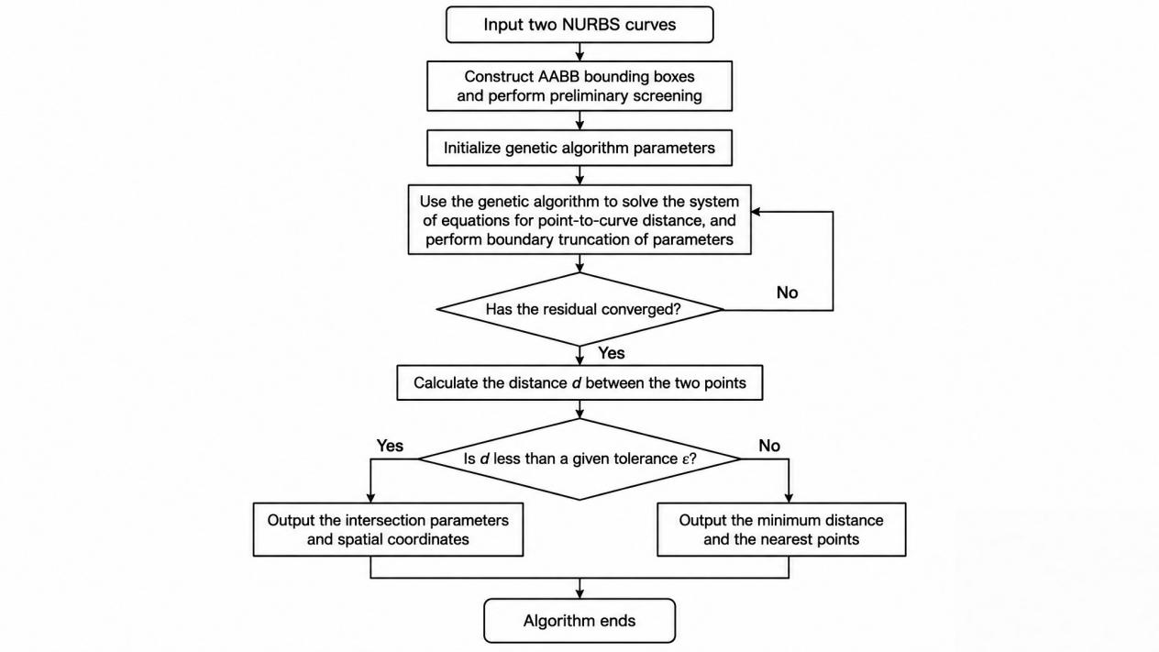
Fig.1 Overall flowchart of the proposed algorithm

5 Numerical Examples and Result Analysis
All test examples adopt 2‑degree NURBS curves. Geometric tolerance $ε={10}^{−6}$, residual tolerance $ε_{r}={10}^{−8}$, maximum iteration limit set to 30. Comparative baseline is the traditional decoupled algorithm consisting of separate intersection module and separate shortest‑distance module. Performance metrics include average iteration steps, single‑run computation time and stability under degenerate cases.

Example 1: Regularly intersecting NURBS curves
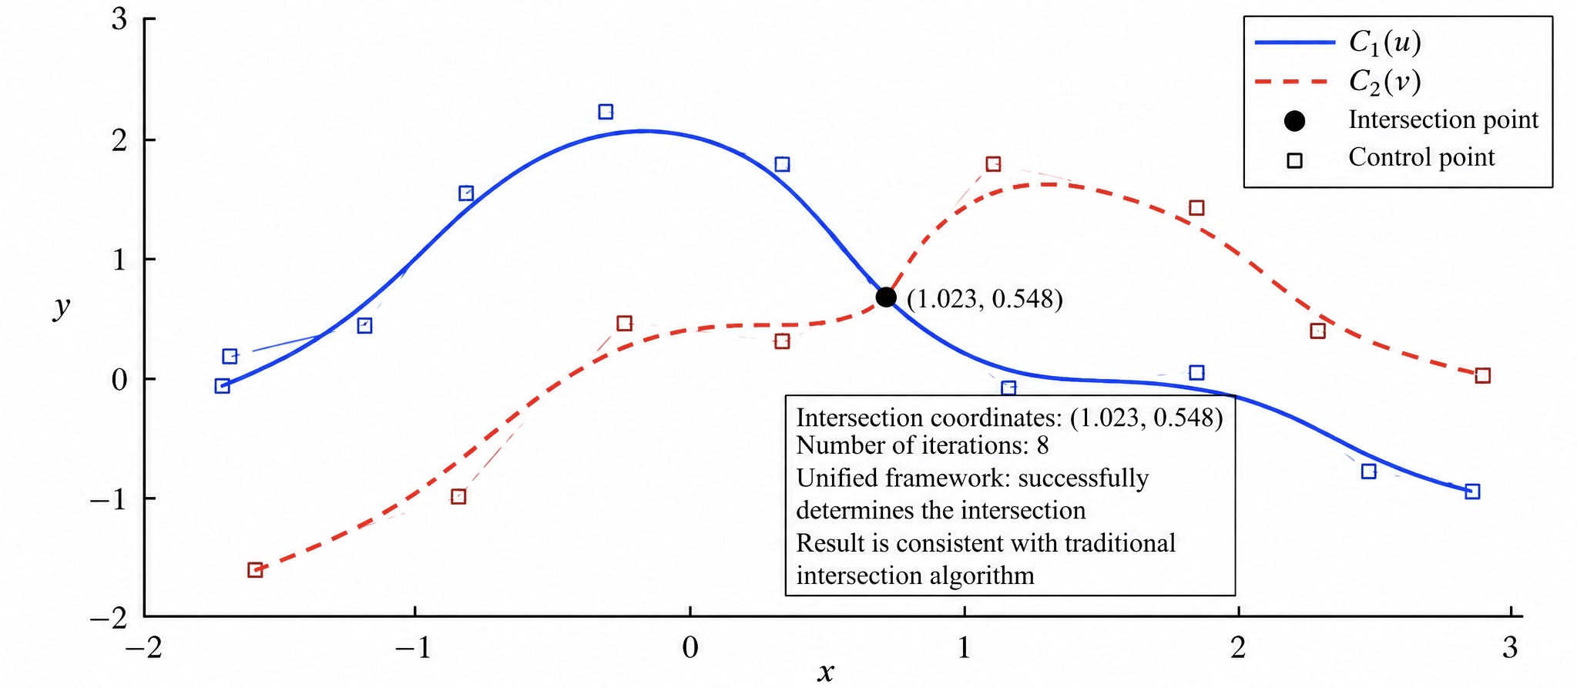
Two 2‑degree NURBS curves intersect in interior parameter regions without boundary contact.

Fig.2 Test case for regular intersecting NURBS curves
Caption: Fig.2 Regular‑intersection test case for NURBS curves. Solid blue line: $C_{1}(u)$; red dashed line: $C_{2}(v)$; solid black circle: solved intersection point; hollow square symbols: control vertices; axes represent 2‑D Cartesian coordinate system. Iteration steps:8. The unified framework correctly detects intersection and produces results consistent with traditional intersection solvers.

Example 2: Closely‑spaced disjoint NURBS curves
Two curves approach each other but remain separated.

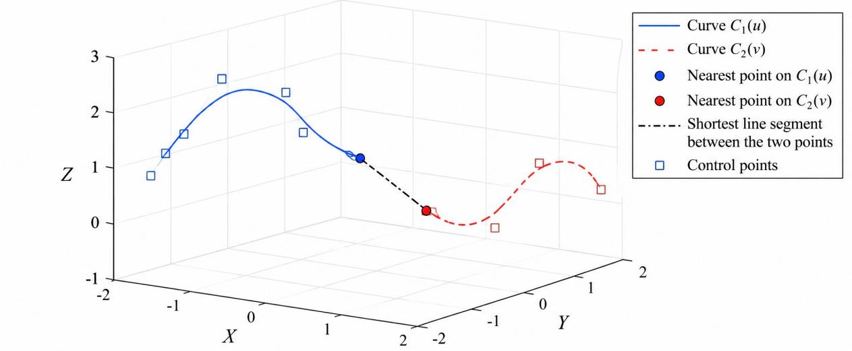
Fig.3 Shortest‑distance test case for disjoint NURBS curves
Caption: Fig.3 Shortest‑distance test for disjoint NURBS curves. Solid line: curve $C_{1}(u)$; dashed line: curve $C_{2}(v)$; solid circular markers denote closest‑point pairs on respective curves; dash‑dot line segment connects the two closest points; hollow squares represent control vertices. After convergence, the algorithm outputs the shortest distance without reporting intersections, matching results from conventional closest‑point solvers.

Example 3: Near‑tangent degenerate case (classic CAD challenge)
Two curves are nearly tangent with very small separation distance, a well‑known degenerate scenario. Traditional decoupled algorithms are prone to misjudgment or numerical oscillation.
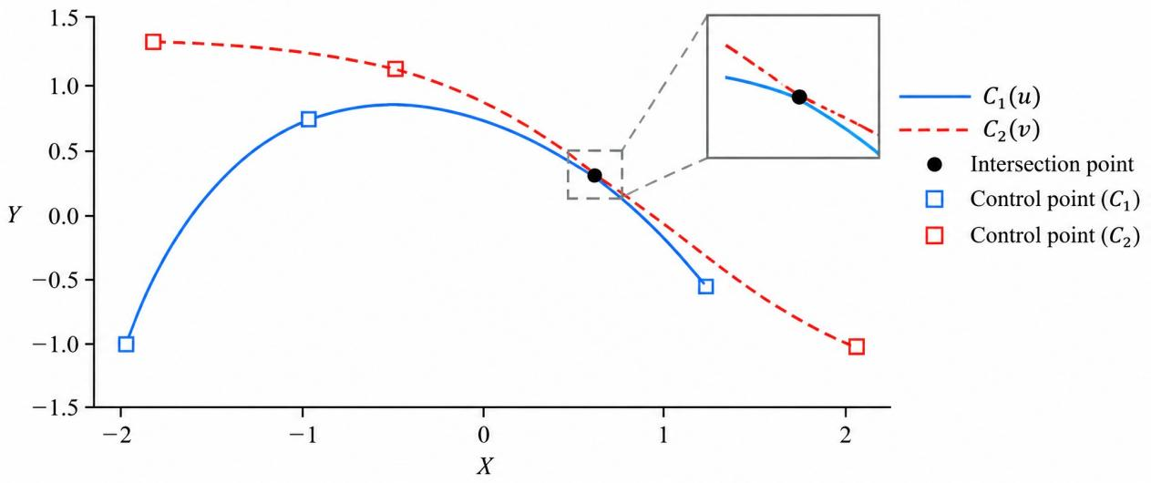Fig.4 Near‑tangent degenerate NURBS‑curve test case
Caption: Fig.4 Near‑tangent degenerate test case. Solid line: $C_{1}(u)$; dashed line: $C_{2}(v)$; solid black circle marks the near‑tangent location; hollow squares are control vertices for $C_{1}(u)$; hollow squares with red borders are control vertices for $C_{2}(v)$. The separation distance is close to tolerance threshold. Benefiting from unified residual criterion, the proposed framework converges stably and avoids oscillation or misclassification induced by mismatched thresholds in two separate solvers.

Tab.1 Performance comparison between proposed algorithm and traditional decoupled algorithm
Case | Geometry type | Algorithm | Avg. iteration steps | Computation time /ms | Classification performance
1 | Regular interior intersection | Traditional decoupled | 10 | 0.87 | Correct, intersection found
1 | Regular interior intersection | Proposed unified framework | 8 | 0.62 | Correct, intersection found
2 | Close disjoint curves | Traditional decoupled | 11 | 0.91 | Correct, shortest distance obtained
2 | Close disjoint curves | Proposed unified framework | 9 | 0.66 | Correct, shortest distance obtained
3 | Near‑tangent degeneration | Traditional decoupled | 16 | 1.24 | Prone to oscillation and misjudgment
3 | Near‑tangent degeneration | Proposed unified framework | 11 | 0.78 | Stable convergence, correct classification

Table note: Test environment: PC equipped with Intel i5 CPU. Each datum is averaged over 10 repeated runs. For traditional decoupled algorithm: perform bounding‑box test first; invoke intersection Newton iteration if overlap detected; otherwise invoke separate shortest‑distance iteration.

Result analysis
- For regular intersection and disjoint cases, the unified framework achieves the same accuracy as decoupled algorithms.
- For near‑tangent degenerate geometry, the proposed framework yields superior robustness and eliminates conflicts from mismatched independent thresholds.
- Computational efficiency: only one iterative pass is required and repeated geometric evaluations are avoided. According to Tab.1, the average computation time is reduced by approximately 20%‑30%.
Limitation: To capture multiple intersection points, multi‑initial‑guess strategies must be incorporated. With a single initial guess, the algorithm converges only to one local solution, which remains for future work.

6 Conclusions
Aiming at redundant computation and poor robustness caused by separate intersection and shortest‑distance solvers for NURBS curves, this paper establishes a unified numerical iterative framework. Intersection and shortest‑distance problems are reformulated into one set of nonlinear residual equations. Within one Newton‑iteration procedure, the geometric state between two NURBS curves is automatically identified: intersection points are output for intersecting configurations; the shortest distance and closest‑point pair are returned for disjoint configurations. Hierarchical AABB pre‑filtering reduces ineffective iterations, and the unified residual criterion improves stability for near‑tangent degenerate geometry. Numerical examples verify the accuracy, robustness and efficiency of the algorithm. The proposed framework can be embedded into underlying modules for CAD geometric modeling and interference detection. Future work will introduce multi‑initial‑guess schemes for capturing multiple intersections and extend the method toward NURBS surfaces.

References
[1]Hoffmann M ,Troll E .Bicycle wheel track design by NURBS and Pythagorean-hodograph curves[J].Journal of Computational and Applied Mathematics,2027,491118076-118076.DOI:10.1016/J.CAM.2026.118076.
[2]Wang Y ,Yu G ,Hu L , et al.Dual NURBS Adaptive Speed Planning for Drive Shaft of Five-Axis Hybrid Machine Tools[J].International Journal of Precision Engineering and Manufacturing,2026,(prepublish):1-18.DOI:10.1007/S12541-026-01522-8.
[3]Garba H U ,Wang T ,Tian Y , et al.High-Speed Precision Machining and Surface Roughness Determination of Freeform Curves Using Galerkin-NURBS Interpolation and Jerk-Limited Trajectory Planning[J].Sensors,2026,26(14):4441-4441.DOI:10.3390/S26144441.
[4]Dong Q ,Ge R ,Xiao H .A NURBS curve interpolation algorithm based on third-order Runge-Kutta and forward speed planning[J].Journal of Physics: Conference Series,2026,3277(1):012091-012091.DOI:10.1088/1742-6596/3277/1/012091.
[5]Xing T ,Zhao Z ,Song Y , et al.NURBS-based optimization of roller bearing profiles for enhanced performance under angular misalignment[J].Chinese Journal of Mechanical Engineering,2026,39100182-100182.DOI:10.1016/J.CJME.2025.100182.
[6]Gao W ,Liu H ,Li M , et al.Double-KANs: Enhancing KANs with simplified NURBS for accurate modeling of discontinuous signals[J].Neurocomputing,2026,694133895-133895.DOI:10.1016/J.NEUCOM.2026.133895.
[7]Liu K ,Zhao J ,Li H , et al.Inverse design of NURBS metasurfaces via deep learning for angular thermal emission control[J].International Journal of Thermal Sciences,2026,228110988-110988.DOI:10.1016/J.IJTHERMALSCI.2026.110988.
[8]Gai Y ,Li G ,Lei N , et al.A reliable method for finding intersections of 2D NURBS curves[J].Results in Applied Mathematics,2026,30100707-100707.DOI:10.1016/J.RINAM.2026.100707.
[9]Wei S ,Zhao K ,Yan H , et al.An explicit and rapid intersection algorithm of plane and NURBS surface in CNC surface machining[J].Scientific Reports,2025,15(1):41824-41824.DOI:10.1038/S41598-025-25765-Z.
[10]Rajab K ,Piegl A L .A Knowledge-Guided Approach to Line NURBS Curve Intersection[J].Computer-Aided Design and Applications,2014,11(1):1-9.DOI:10.1080/16864360.2013.829966.

